Lab Taks-3

Question- 1

Draw five storied building with windows and a front door

Graph Plot (Picture)-
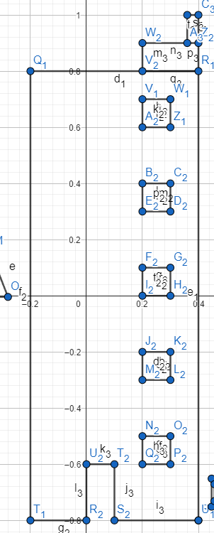

Code-
#include <windows.h>
#include<math.h>
#include <GL/glut.h>

void House()
{
glBegin(GL_POLYGON);
glColor3f(0.0f, 0.0f, 0.0f);
glVertex2f(-0.2, 0.8);
glVertex2f(-0.2, -0.8);
glVertex2f(0.4, -0.8);
glVertex2f(0.4, 0.8);
glEnd();

glBegin(GL_POLYGON);
glColor3f(1.0f, 1.0f, 1.0f);
glVertex2f(0, -0.8);
glVertex2f(0.1, -0.8);
glVertex2f(0.1, -0.6);
glVertex2f(0, -0.6);
glEnd();

glBegin(GL_POLYGON);
glColor3f(1.0f, 1.0f, 1.0f);
glVertex2f(0.2, -0.5);
glVertex2f(0.2, -0.6);
glVertex2f(0.3, -0.6);
glVertex2f(0.3, -0.5);

glEnd();

glBegin(GL_POLYGON);
glColor3f(0.0f, 0.0f, 0.0f);
glVertex2f(0.2, 0.9);
glVertex2f(0.4, 0.9);
glVertex2f(0.4, 0.8);
glVertex2f(0.2, 0.8);

glEnd();
glBegin(GL_POLYGON);
glColor3f(0.0f, 0.0f, 0.0f);
glVertex2f(0.36, 1);
glVertex2f(0.36, 0.9);
glVertex2f(0.4, 0.9);
glVertex2f(0.4, 1);

glEnd();
glFlush();

}

void window(float x, float y)
{
glBegin(GL_POLYGON);
glColor3f(1.0f, 1.0f, 1.0f);
glVertex2f(0.2 + x, 0.7 + y);
glVertex2f(0.3 + x, 0.7 + y);
glVertex2f(0.3 + x, 0.6 + y);
glVertex2f(0.2 + x, 0.6 + y);

glEnd();

glFlush();

}

void display() {
glClearColor(1.0f, 1.0f, 1.0f, 1.0f);
glClear(GL_COLOR_BUFFER_BIT);
glLineWidth(7.5);
House();
window(0.0, 0.0);
window(0.0, -0.3);
window(0.0, -0.6);
window(0.0, -0.9);

glEnd();
glEnd();
}

int main(int argc, char** argv) {

glutInit(&argc, argv);

glutCreateWindow("Vertex, Primitive & Color");

glutInitWindowSize(320, 320);

glutDisplayFunc(display);

glutMainLoop();

return 0;

}

Output Screenshot (Full Screen)-
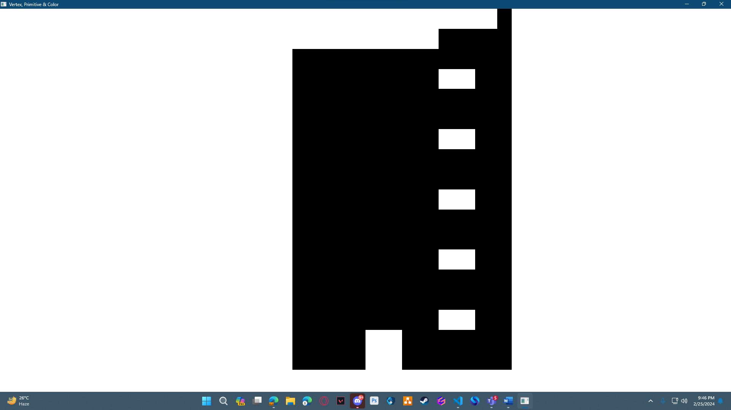

Question- 2

Draw a tree

Graph Plot (Picture)-

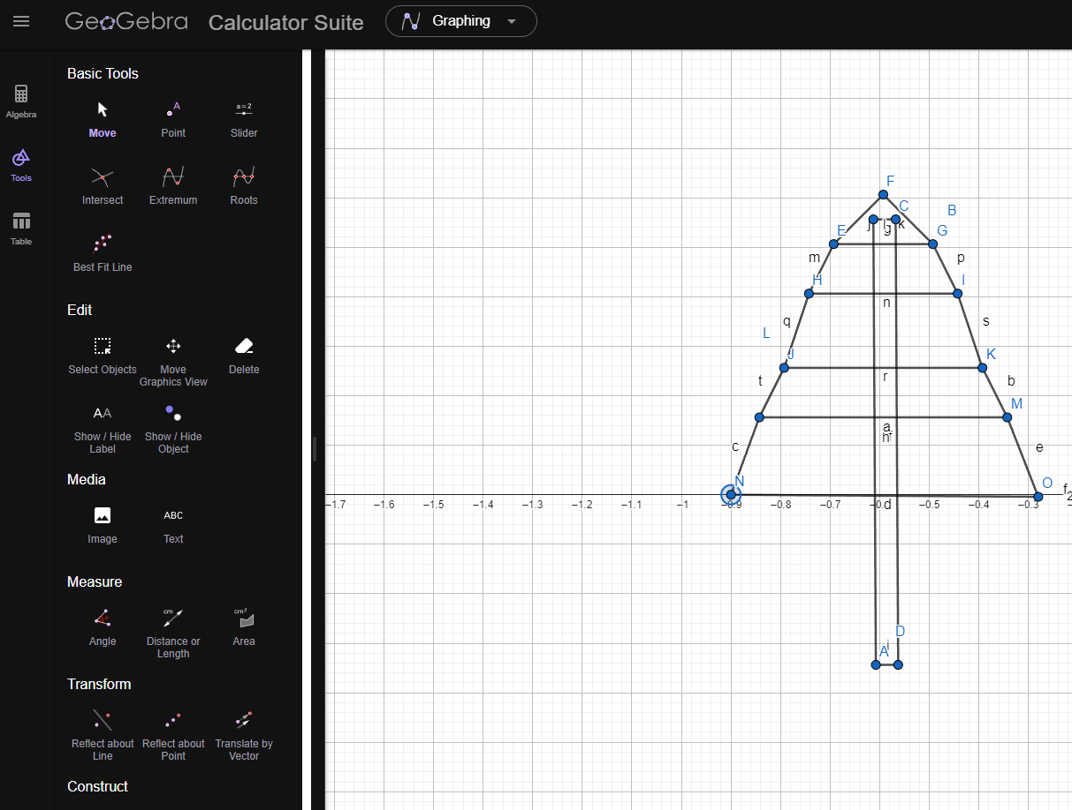
Code-
#include <windows.h>
#include<math.h>
#include <GL/glut.h>

void initGL() {

glClearColor(0.0f, 0.0f, 0.0f, 0.0f);

}

void display() {
glClearColor(1.0f, 1.0f, 1.0f, 1.0f);
glClear(GL_COLOR_BUFFER_BIT);
glLineWidth(7.5);

glBegin(GL_POLYGON);
glColor4f(1.0f, 0.5f, 0.0f, 0.0f);
glVertex2f(-0.6128255393419, 0.5563316792327);
glVertex2f(-0.5678255393419, 0.5563316792327);

glVertex2f(-0.5678255393419, 0.5563316792327);
glVertex2f(-0.5628255393419, -0.3436683207673);

glVertex2f(-0.5628255393419, -0.3436683207673);
glVertex2f(-0.6078255393419, -0.3436683207673);

glVertex2f(-0.6078255393419, -0.3436683207673);
glVertex2f(-0.6128255393419, 0.5563316792327);

glEnd();

glBegin(GL_POLYGON);
glColor3f(0.0f, 1.0f, 0.0f);
glVertex2f(-0.5928255393419, 0.6063316792327);
glVertex2f(-0.6928255393419, 0.5063316792327);

glVertex2f(-0.6928255393419, 0.5063316792327);
glVertex2f(-0.4928255393419, 0.5063316792327);

glVertex2f(-0.4928255393419, 0.5063316792327);
glVertex2f(-0.5928255393419, 0.6063316792327);

glEnd();

glBegin(GL_POLYGON);
glColor3f(0.0f, 1.0f, 0.0f);
glVertex2f(-0.6928255393419, 0.5063316792327);
glVertex2f(-0.4928255393419, 0.5063316792327);

glVertex2f(-0.4928255393419, 0.5063316792327);
glVertex2f(-0.4428255393419, 0.4063316792327);

glVertex2f(-0.4428255393419, 0.4063316792327);
glVertex2f(-0.7428255393419, 0.4063316792327);

glVertex2f(-0.7428255393419, 0.4063316792327);
glVertex2f(-0.6928255393419, 0.5063316792327);
glEnd();

glBegin(GL_POLYGON);
glColor3f(0.0f, 1.0f, 0.0f);
glVertex2f(-0.7428255393419, 0.4063316792327);
glVertex2f(-0.4428255393419, 0.4063316792327);

glVertex2f(-0.4428255393419, 0.4063316792327);
glVertex2f(-0.3928255393419, 0.2563316792327);

glVertex2f(-0.3928255393419, 0.2563316792327);
glVertex2f(-0.7928255393419, 0.2563316792327);

glVertex2f(-0.7928255393419, 0.2563316792327);
glVertex2f(-0.7428255393419, 0.4063316792327);
glEnd();

glBegin(GL_POLYGON);
glColor3f(0.0f, 1.0f, 0.0f);
glVertex2f(-0.7928255393419, 0.2563316792327);
glVertex2f(-0.3928255393419, 0.2563316792327);

glVertex2f(-0.3928255393419, 0.2563316792327);
glVertex2f(-0.3428255393419, 0.1563316792327);

glVertex2f(-0.8428255393419, 0.1563316792327);
glVertex2f(-0.8428255393419, 0.1563316792327);

glVertex2f(-0.8428255393419, 0.1563316792327);
glVertex2f(-0.7928255393419, 0.2563316792327);
glEnd();

glBegin(GL_POLYGON);
glColor3f(0.0f, 1.0f, 0.0f);
glVertex2f(-0.8428255393419, 0.1563316792327);
glVertex2f(-0.3428255393419, 0.1563316792327);

glVertex2f(-0.3928255393419, 0.2563316792327);
glVertex2f(-0.2802093512555, -0.0041117831013);

glVertex2f(-0.2802093512555, -0.0041117831013);
glVertex2f(-0.9, 0);

glVertex2f(-0.9, 0);
glVertex2f(-0.8428255393419, 0.1563316792327);
glEnd();
glEnd();
glFlush();

}

int main(int argc, char** argv) {

glutInit(&argc, argv);

glutCreateWindow("Vertex, Primitive & Color");

glutInitWindowSize(320, 320);

glutDisplayFunc(display);

initGL();

glutMainLoop();

return 0;

}

Output Screenshot (Full Screen)-
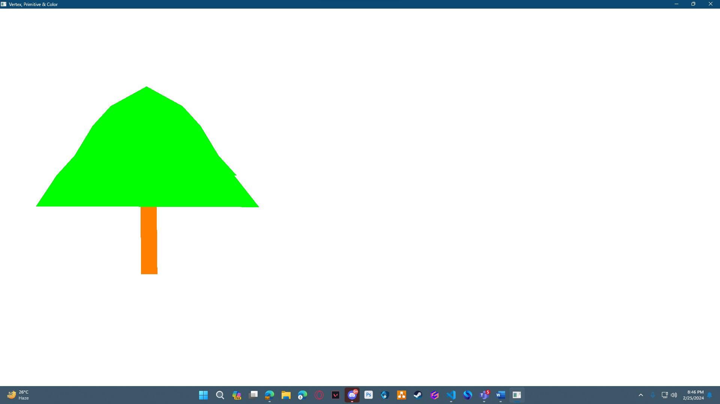

Question- 3

Draw a lamppost with black background

Graph Plot (Picture)-
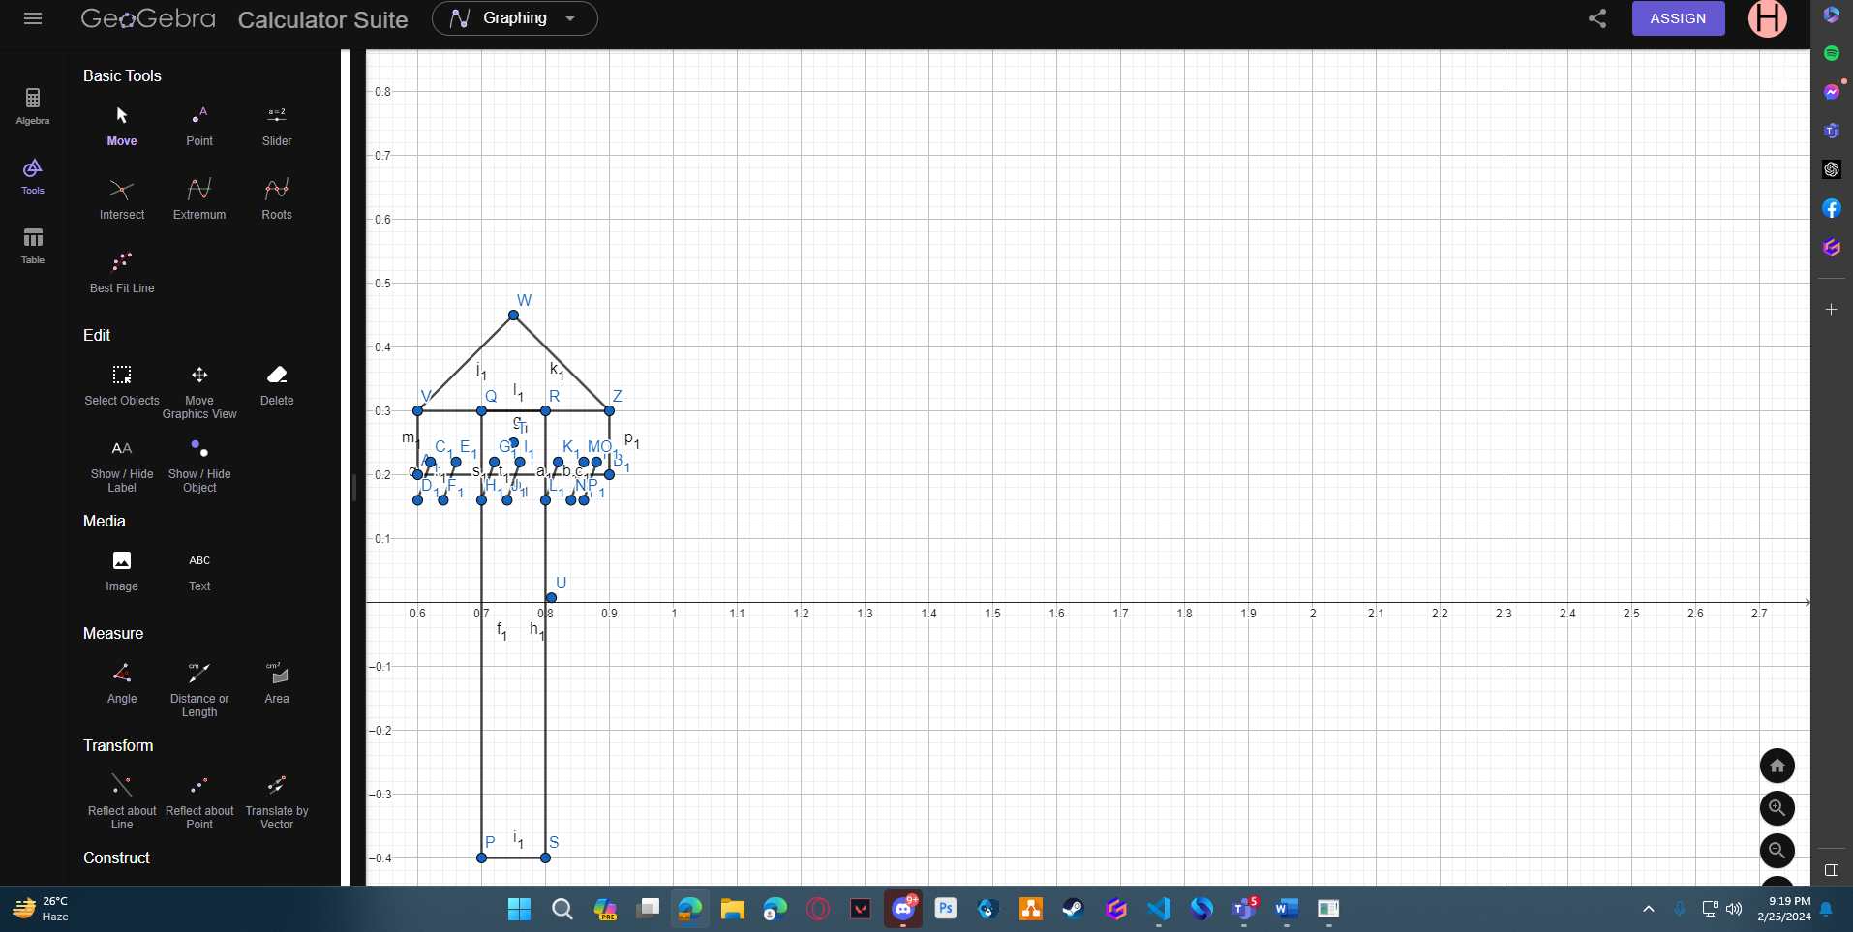
Code-
#include <windows.h>
#include<math.h>
#include <GL/glut.h>

void initGL() {

glClearColor(0.0, 0.0, 0.0, 1.0);

}
void lamp()
{
glBegin(GL_POLYGON);
glColor3f(0.1f, 0.0f, 0.0f);
glVertex2f(0.7, -0.4);
glVertex2f(0.8, -0.4);
glVertex2f(0.8, 0.3);
glVertex2f(0.7, 0.3);
glEnd();

glBegin(GL_POLYGON);
glColor4f(1.0f, 1.0f, 0.0f, 0.0f);
glVertex2f(0.6, 0.3);
glVertex2f(0.6, 0.2);
glVertex2f(0.9, 0.2);
glVertex2f(0.9, 0.3);
glEnd();

glBegin(GL_POLYGON);
glColor3f(0.0f, 0.1f, 0.1f);
glVertex2f(0.75, 0.45);
glVertex2f(0.6, 0.3);
glVertex2f(0.9, 0.3);

glEnd();

glFlush();

}
void lamp_line()
{
glLineWidth(3);
glBegin(GL_LINES);
glColor4f(1.0f, 1.0f, 0.0f, 0.0f);
glVertex2f(0.62, 0.22);
glVertex2f(0.6, 0.16);
glVertex2f(0.66, 0.22);
glVertex2f(0.64, 0.16);
glVertex2f(0.72, 0.22);
glVertex2f(0.7, 0.16);

glVertex2f(0.76, 0.22);
glVertex2f(0.74, 0.16);

glVertex2f(0.82, 0.22);
glVertex2f(0.8, 0.16);

glVertex2f(0.86, 0.22);
glVertex2f(0.84, 0.16);
glVertex2f(0.88, 0.22);
glVertex2f(0.86, 0.16);

glEnd();
glFlush();
}

void display() {
glClearColor(0.0, 0.0, 0.0, 1.0);
glClear(GL_COLOR_BUFFER_BIT);
glLineWidth(7.5);

lamp();

lamp_line();

glEnd();
glEnd();

}

int main(int argc, char** argv) {

glutInit(&argc, argv);

glutCreateWindow("Vertex, Primitive & Color");

glutInitWindowSize(320, 320);

glutDisplayFunc(display);

initGL();

glutMainLoop();

return 0;

}

Output Screenshot (Full Screen)-
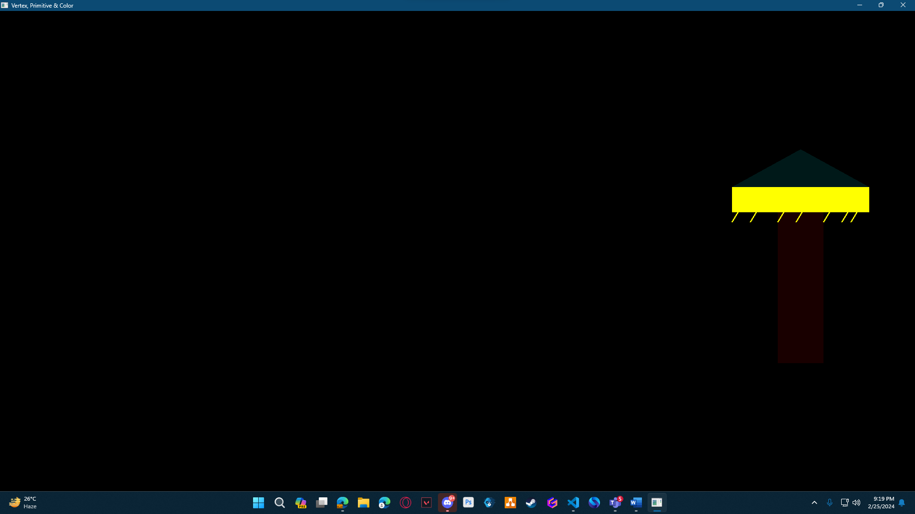

Question- 4

Draw a bench

Graph Plot (Picture)-
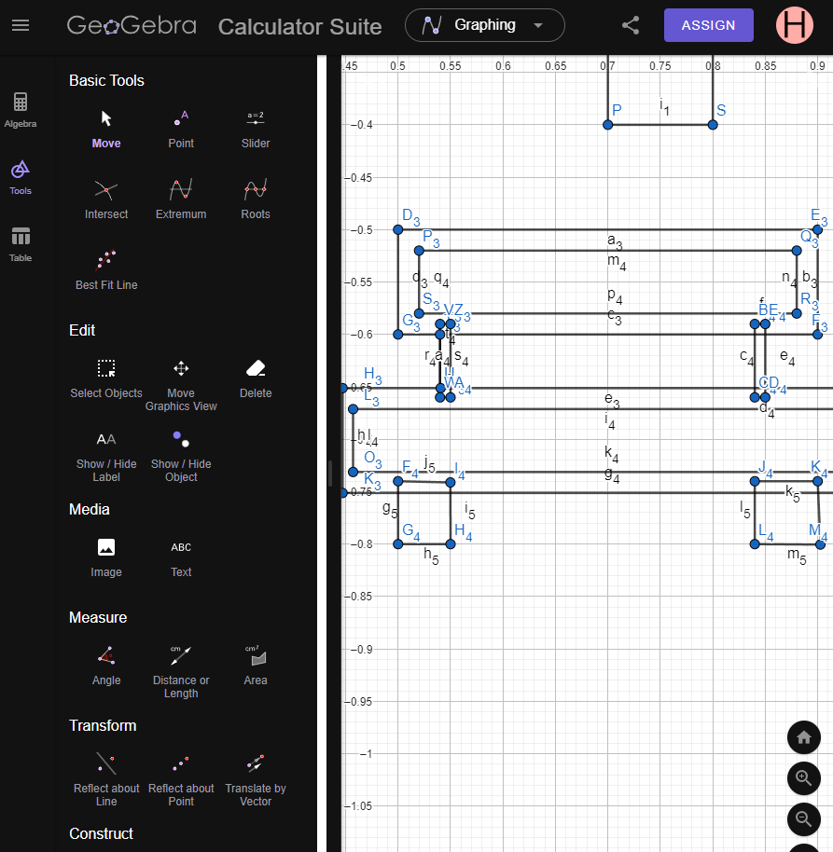

Code-

#include <windows.h>
#include<math.h>
#include <GL/glut.h>

void table()
{
glBegin(GL_POLYGON);
glColor3f(0.0f, 0.0f, 0.0f);
glVertex2f(0.5, -0.5);
glVertex2f(0.5, -0.6);
glVertex2f(0.9, -0.6);
glVertex2f(0.9, -0.5);

glEnd();
glBegin(GL_POLYGON);
glColor3f(1.0f, 1.0f, 1.0f);
glVertex2f(0.52, -0.52);
glVertex2f(0.52, -0.58);
glVertex2f(0.88, -0.58);
glVertex2f(0.88, -0.52);

glEnd();
glBegin(GL_POLYGON);
glColor3f(0.0f, 0.0f, 0.0f);
glVertex2f(0.54, -0.59);
glVertex2f(0.55, -0.59);
glVertex2f(0.54, -0.66);
glVertex2f(0.55, -0.66);

glEnd();

glBegin(GL_POLYGON);
glColor3f(0.0f, 0.0f, 0.0f);
glVertex2f(0.84, -0.59);
glVertex2f(0.85, -0.59);
glVertex2f(0.85, -0.66);
glVertex2f(0.84, -0.66);

glEnd();

glBegin(GL_POLYGON);
glColor3f(0.0f, 0.0f, 0.0f);
glVertex2f(0.4470868438943, -0.6512046352296);
glVertex2f(0.4470868438943, -0.7512046352296);
glVertex2f(0.9470868438943, -0.7512046352296);
glVertex2f(0.9470868438943, -0.6512046352296);

glEnd();

glBegin(GL_POLYGON);
glColor3f(1.0f, 1.0f, 1.0f);
glVertex2f(0.4570868438943, -0.6712046352296);
glVertex2f(0.4570868438943, -0.7312046352296);
glVertex2f(0.9370868438943, -0.7312046352296);
glVertex2f(0.9370868438943, -0.6712046352296);

glEnd();

glBegin(GL_POLYGON);
glColor3f(0.0f, 0.0f, 0.0f);
glVertex2f(0.5, -0.74);
glVertex2f(0.5, -0.8);
glVertex2f(0.55, -0.8);
glVertex2f(0.5498864567762, -0.7411413975327);

glEnd();
glBegin(GL_POLYGON);
glColor3f(0.0f, 0.0f, 0.0f);
glVertex2f(0.84, -0.74);
glVertex2f(0.84, -0.8);
glVertex2f(0.9025843531667, -0.8004109426671);
glVertex2f(0.9, -0.74);

glEnd();
glEnd();

glFlush();

}

void display() {
glClearColor(1.0f, 1.0f, 1.0f, 1.0f);
glClear(GL_COLOR_BUFFER_BIT);
glLineWidth(7.5);

table();

}

int main(int argc, char** argv) {

glutInit(&argc, argv);

glutCreateWindow("Vertex, Primitive & Color");

glutInitWindowSize(320, 320);

glutDisplayFunc(display);

glutMainLoop();

return 0;

}

Output Screenshot (Full Screen)-
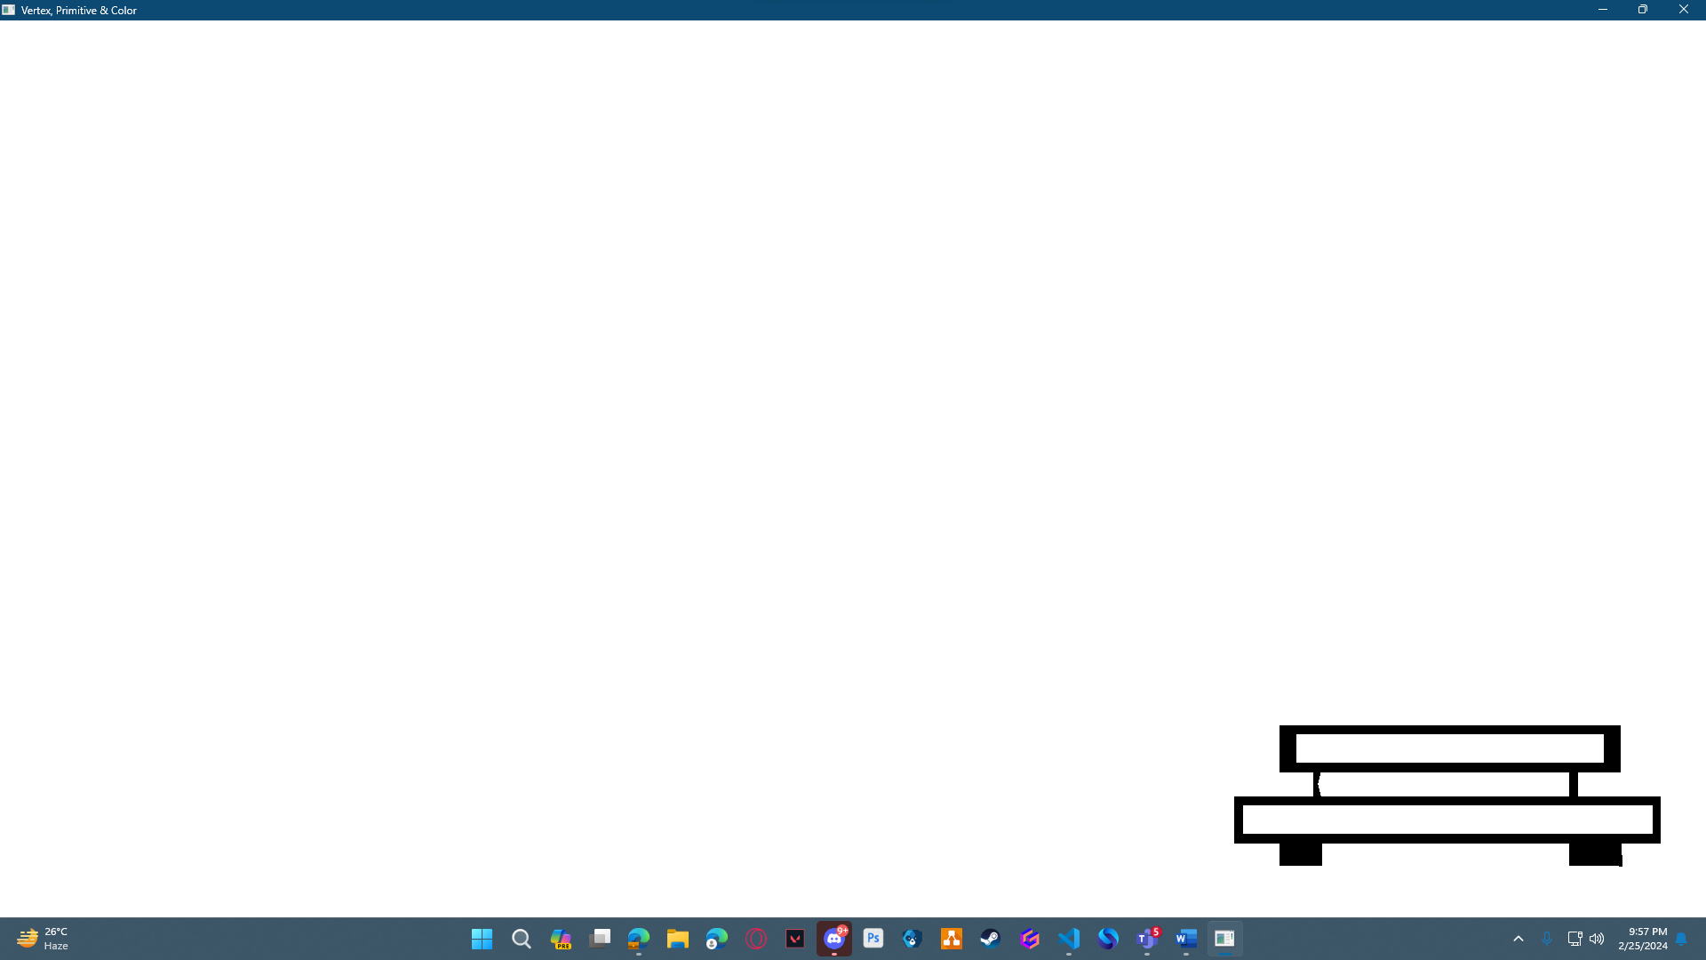

Question- 5

Use the building, tree, lamppost and bench to create a scenario

Graph Plot (Picture)-
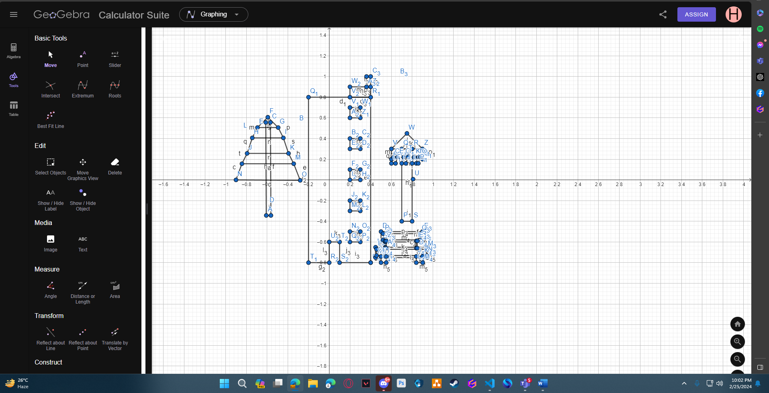

Code-
#include <windows.h>
#include<math.h>
#include <GL/glut.h>

void House()
{
glBegin(GL_POLYGON);
glColor3f(0.0f, 0.0f, 0.0f);
glVertex2f(-0.2, 0.8);
glVertex2f(-0.2, -0.8);
glVertex2f(0.4, -0.8);
glVertex2f(0.4, 0.8);
glEnd();

glBegin(GL_POLYGON);
glColor3f(1.0f, 1.0f, 1.0f);
glVertex2f(0, -0.8);
glVertex2f(0.1, -0.8);
glVertex2f(0.1, -0.6);
glVertex2f(0, -0.6);
glEnd();

glBegin(GL_POLYGON);
glColor3f(1.0f, 1.0f, 1.0f);
glVertex2f(0.2, -0.5);
glVertex2f(0.2, -0.6);
glVertex2f(0.3, -0.6);
glVertex2f(0.3, -0.5);

glEnd();

glBegin(GL_POLYGON);
glColor3f(0.0f, 0.0f, 0.0f);
glVertex2f(0.2, 0.9);
glVertex2f(0.4, 0.9);
glVertex2f(0.4, 0.8);
glVertex2f(0.2, 0.8);

glEnd();
glBegin(GL_POLYGON);
glColor3f(0.0f, 0.0f, 0.0f);
glVertex2f(0.36, 1);
glVertex2f(0.36, 0.9);
glVertex2f(0.4, 0.9);
glVertex2f(0.4, 1);

glEnd();
glFlush();

}

void window(float x, float y)
{
glBegin(GL_POLYGON);
glColor3f(1.0f, 1.0f, 1.0f);
glVertex2f(0.2 + x, 0.7 + y);
glVertex2f(0.3 + x, 0.7 + y);
glVertex2f(0.3 + x, 0.6 + y);
glVertex2f(0.2 + x, 0.6 + y);

glEnd();

glFlush();

}

void table()
{
glBegin(GL_POLYGON);
glColor3f(0.0f, 0.0f, 0.0f);
glVertex2f(0.5, -0.5);
glVertex2f(0.5, -0.6);
glVertex2f(0.9, -0.6);
glVertex2f(0.9, -0.5);

glEnd();
glBegin(GL_POLYGON);
glColor3f(1.0f, 1.0f, 1.0f);
glVertex2f(0.52, -0.52);
glVertex2f(0.52, -0.58);
glVertex2f(0.88, -0.58);
glVertex2f(0.88, -0.52);

glEnd();
glBegin(GL_POLYGON);
glColor3f(0.0f, 0.0f, 0.0f);
glVertex2f(0.54, -0.59);
glVertex2f(0.55, -0.59);
glVertex2f(0.54, -0.66);
glVertex2f(0.55, -0.66);

glEnd();

glBegin(GL_POLYGON);
glColor3f(0.0f, 0.0f, 0.0f);
glVertex2f(0.84, -0.59);
glVertex2f(0.85, -0.59);
glVertex2f(0.85, -0.66);
glVertex2f(0.84, -0.66);

glEnd();

glBegin(GL_POLYGON);
glColor3f(0.0f, 0.0f, 0.0f);
glVertex2f(0.4470868438943, -0.6512046352296);
glVertex2f(0.4470868438943, -0.7512046352296);
glVertex2f(0.9470868438943, -0.7512046352296);
glVertex2f(0.9470868438943, -0.6512046352296);

glEnd();

glBegin(GL_POLYGON);
glColor3f(1.0f, 1.0f, 1.0f);
glVertex2f(0.4570868438943, -0.6712046352296);
glVertex2f(0.4570868438943, -0.7312046352296);
glVertex2f(0.9370868438943, -0.7312046352296);
glVertex2f(0.9370868438943, -0.6712046352296);

glEnd();

glBegin(GL_POLYGON);
glColor3f(0.0f, 0.0f, 0.0f);
glVertex2f(0.5, -0.74);
glVertex2f(0.5, -0.8);
glVertex2f(0.55, -0.8);
glVertex2f(0.5498864567762, -0.7411413975327);

glEnd();
glBegin(GL_POLYGON);
glColor3f(0.0f, 0.0f, 0.0f);
glVertex2f(0.84, -0.74);
glVertex2f(0.84, -0.8);
glVertex2f(0.9025843531667, -0.8004109426671);
glVertex2f(0.9, -0.74);

glEnd();
glEnd();

glFlush();

}
void tree()
{

glBegin(GL_POLYGON);
glColor4f(1.0f, 0.5f, 0.0f, 0.0f);
glVertex2f(-0.6128255393419, 0.5563316792327);
glVertex2f(-0.5678255393419, 0.5563316792327);

glVertex2f(-0.5678255393419, 0.5563316792327);
glVertex2f(-0.5628255393419, -0.3436683207673);

glVertex2f(-0.5628255393419, -0.3436683207673);
glVertex2f(-0.6078255393419, -0.3436683207673);

glVertex2f(-0.6078255393419, -0.3436683207673);
glVertex2f(-0.6128255393419, 0.5563316792327);

glEnd();

glBegin(GL_POLYGON);
glColor3f(0.0f, 1.0f, 0.0f);
glVertex2f(-0.5928255393419, 0.6063316792327);
glVertex2f(-0.6928255393419, 0.5063316792327);

glVertex2f(-0.6928255393419, 0.5063316792327);
glVertex2f(-0.4928255393419, 0.5063316792327);

glVertex2f(-0.4928255393419, 0.5063316792327);
glVertex2f(-0.5928255393419, 0.6063316792327);

glEnd();

glBegin(GL_POLYGON);
glColor3f(0.0f, 1.0f, 0.0f);
glVertex2f(-0.6928255393419, 0.5063316792327);
glVertex2f(-0.4928255393419, 0.5063316792327);

glVertex2f(-0.4928255393419, 0.5063316792327);
glVertex2f(-0.4428255393419, 0.4063316792327);

glVertex2f(-0.4428255393419, 0.4063316792327);
glVertex2f(-0.7428255393419, 0.4063316792327);

glVertex2f(-0.7428255393419, 0.4063316792327);
glVertex2f(-0.6928255393419, 0.5063316792327);
glEnd();

glBegin(GL_POLYGON);
glColor3f(0.0f, 1.0f, 0.0f);
glVertex2f(-0.7428255393419, 0.4063316792327);
glVertex2f(-0.4428255393419, 0.4063316792327);

glVertex2f(-0.4428255393419, 0.4063316792327);
glVertex2f(-0.3928255393419, 0.2563316792327);

glVertex2f(-0.3928255393419, 0.2563316792327);
glVertex2f(-0.7928255393419, 0.2563316792327);

glVertex2f(-0.7928255393419, 0.2563316792327);
glVertex2f(-0.7428255393419, 0.4063316792327);
glEnd();

glBegin(GL_POLYGON);
glColor3f(0.0f, 1.0f, 0.0f);
glVertex2f(-0.7928255393419, 0.2563316792327);
glVertex2f(-0.3928255393419, 0.2563316792327);

glVertex2f(-0.3928255393419, 0.2563316792327);
glVertex2f(-0.3428255393419, 0.1563316792327);

glVertex2f(-0.8428255393419, 0.1563316792327);
glVertex2f(-0.8428255393419, 0.1563316792327);

glVertex2f(-0.8428255393419, 0.1563316792327);
glVertex2f(-0.7928255393419, 0.2563316792327);
glEnd();

glBegin(GL_POLYGON);
glColor3f(0.0f, 1.0f, 0.0f);
glVertex2f(-0.8428255393419, 0.1563316792327);
glVertex2f(-0.3428255393419, 0.1563316792327);

glVertex2f(-0.3928255393419, 0.2563316792327);
glVertex2f(-0.2802093512555, -0.0041117831013);

glVertex2f(-0.2802093512555, -0.0041117831013);
glVertex2f(-0.9, 0);

glVertex2f(-0.9, 0);
glVertex2f(-0.8428255393419, 0.1563316792327);
glEnd();
glEnd();
glFlush();
}
void lamp()
{
glBegin(GL_POLYGON);
glColor4f(0.0f, 1.0f, 1.0f, 1.0f);
glVertex2f(0.7, -0.4);
glVertex2f(0.8, -0.4);
glVertex2f(0.8, 0.3);
glVertex2f(0.7, 0.3);
glEnd();

glBegin(GL_POLYGON);
glColor4f(1.0f, 1.0f, 0.0f, 0.0f);
glVertex2f(0.6, 0.3);
glVertex2f(0.6, 0.2);
glVertex2f(0.9, 0.2);
glVertex2f(0.9, 0.3);
glEnd();

glBegin(GL_POLYGON);
glColor3f(0.0f, 0.1f, 0.1f);
glVertex2f(0.75, 0.45);
glVertex2f(0.6, 0.3);
glVertex2f(0.9, 0.3);

glEnd();

glFlush();

}
void lamp_line()
{
glLineWidth(3);
glBegin(GL_LINES);
glColor4f(1.0f, 1.0f, 0.0f, 0.0f);
glVertex2f(0.62, 0.22);
glVertex2f(0.6, 0.16);
glVertex2f(0.66, 0.22);
glVertex2f(0.64, 0.16);
glVertex2f(0.72, 0.22);
glVertex2f(0.7, 0.16);

glVertex2f(0.76, 0.22);
glVertex2f(0.74, 0.16);

glVertex2f(0.82, 0.22);
glVertex2f(0.8, 0.16);

glVertex2f(0.86, 0.22);
glVertex2f(0.84, 0.16);
glVertex2f(0.88, 0.22);
glVertex2f(0.86, 0.16);

glEnd();
glFlush();
}

void display() {
glClearColor(1.0f, 1.0f, 1.0f, 1.0f);
glClear(GL_COLOR_BUFFER_BIT);
glLineWidth(7.5);
House();
window(0.0, 0.0);
window(0.0, -0.3);
window(0.0, -0.6);
window(0.0, -0.9);
table();
tree();
lamp();
lamp_line();
glEnd();
glEnd();
}

int main(int argc, char** argv) {

glutInit(&argc, argv);

glutCreateWindow("Vertex, Primitive & Color");

glutInitWindowSize(320, 320);

glutDisplayFunc(display);

glutMainLoop();

return 0;

}

Output Screenshot (Full Screen)-
